Week 6 - WESO Practice

Binary Practice

- Convert the following decimal numbers to binary
9 ______
18 ______
27 ______
- Convert the following binary numbers to decimal
1000 ______
101 ______
1010101 ______

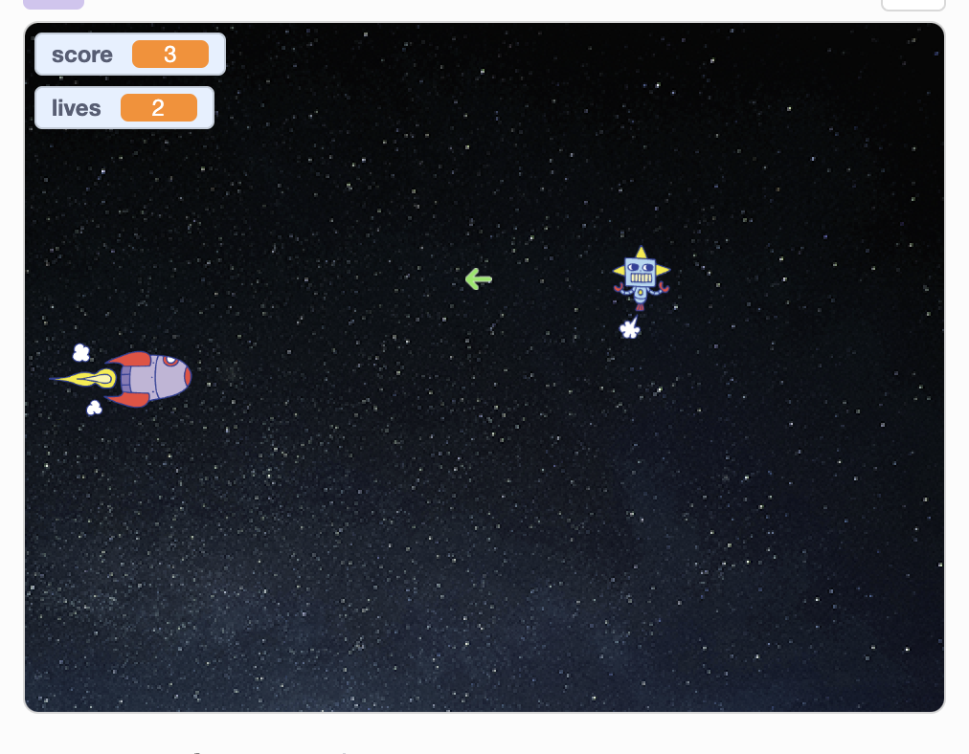
Coding Challenge
- Player makes the rocket ship go up and down with the arrow keys. The ship cannot go left or right.
- Player can fire a shot with the space bar. The shot travels from left to right in a straight line.
- The robot appears on the right side of the screen and zig-zags towards the rocket, shooting shots one after the other. The robot always moves steadily right to left, but randomly zig-zags up and down and changes speed as it moves left.
- If the rocket’s shot hits the robot, the score goes up by one and the robot is destroyed. It will start again on the right side of the screen a few seconds later (whatever seems to make sense)
- If the robot’s shot hits the rocket, the rocket is destroyed and the player loses one life.
- If the robot hits the rocket, both the rocket and the robot are destroyed. The score goes up by one and the player loses one life.
- When the player loses all lives the game is over.
- The robot and rocket should have a short animation when they are destroyed.
- The shots should disappear when they hit something, since ya know they got destroyed
- The robot and rocket should not be able to shoot after they’ve been destroyed. They can shoot again when the shooter (robot or rocket) comes back to life.
- The rocket should not come back to life until the robot is at the far edge of the screen, otherwise it could get destroyed again with no chance for self-defense.

